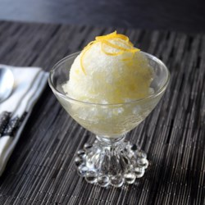

Chef John's Lemon Ice

Prep Time 10 min Ready In 3 hr 10 min

8 Servings

Ingredients
4 cups cold water
7/8 cup white sugar
2 Tbsp lemon zest
1 cup freshly squeezed lemon juice
1 tsp lemon extract

Directions
- Dissolve sugar in water in a pot over medium heat, whisking while water heats up.
- When water is clear, remove pan from heat. While water is still warm, add lemon zest. Allow to cool to room temperature before adding lemon juice.
- Whisk in lemon juice and lemon extract. Pour into a 9 x 13 baking pan. Place in freezer until ice starts to form around the edges, about 40 to 45 minutes.
- Use a fork to stir up ice. Do this every 20 to 30 minutes until lemon ice reaches your preferred texture, 2 1/2 to 3 hours.

